APP PROTOTYPE
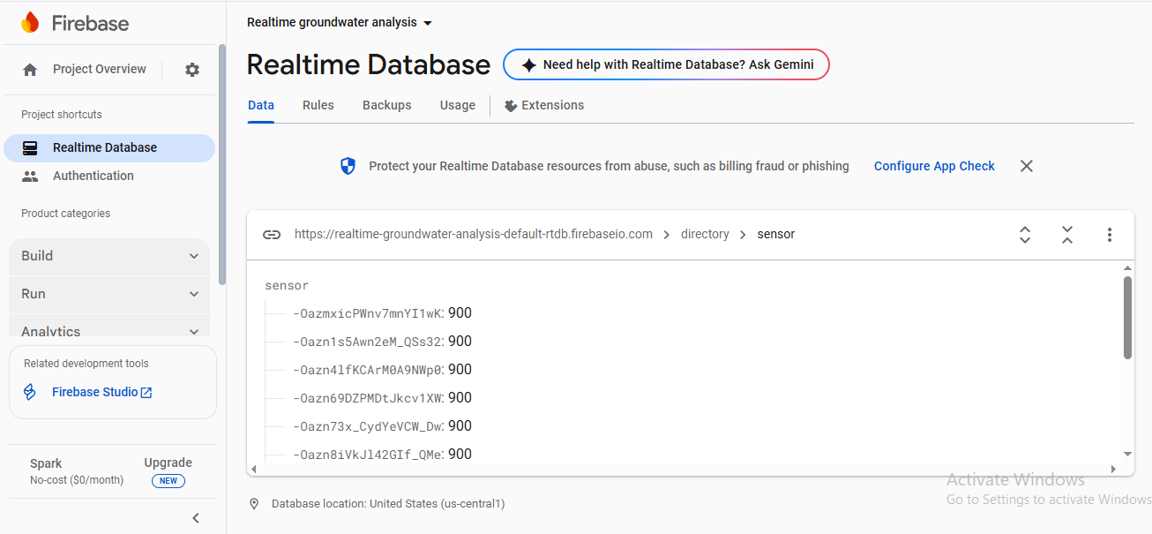
HARDWARE – THIS CONSISTS OF AN MICROCONTROLLER ESP32, HX710AB, PIPE (WHICH WILL BE DIPPED IN WATER ) A USB CONNECTED TO THE DEVICE.
